Accessing Creating Editing and Running Normalization Rules and Processes with Varied Cataloging Roles | 
Yoel Kortick.
Senior Librarian

This document will explain the different user roles relating to normalization rules and normalization processes.

By having one user with one or a combination of the following roles the institution can be very specific about what each user can and cannot do.

The role “Cataloger” can:
- Create new normalization rules
- Edit existing normalization rules
- Run a normalization process on one record from within the metadata editor

The role “Catalog Manager” can:
- Create new normalization rules
- Edit existing normalization rules
- Run a normalization process on one record from within the metadata editor
- Run a normalization process on a set

The role “Catalog Administrator” without checkbox “Read Only” can:
- View and Edit existing normalization processes
- Add new normalization processes

The role “Catalog Administrator” with checkbox “Read Only” can:
- View existing normalization processes

ONE

User Madeline Matar, ID MadelineM613, has only roles “Cataloger” and “Patron”

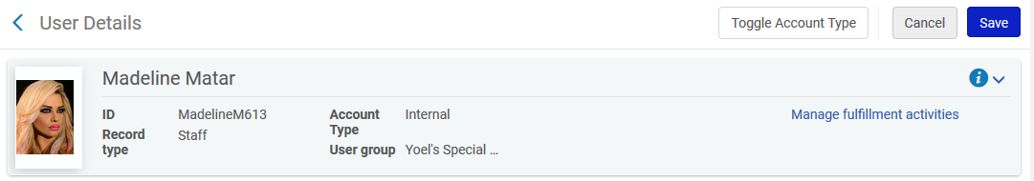

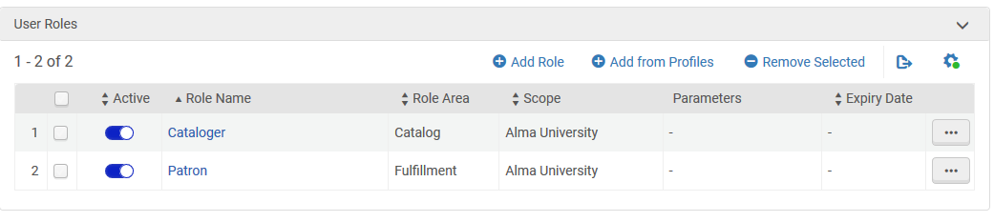

She does not have these roles:
- Catalog Administrator
- Catalog Manager

TWO

We see that Madeline can edit existing normalization rules and add new normalization rules

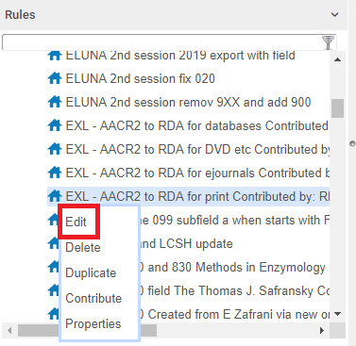

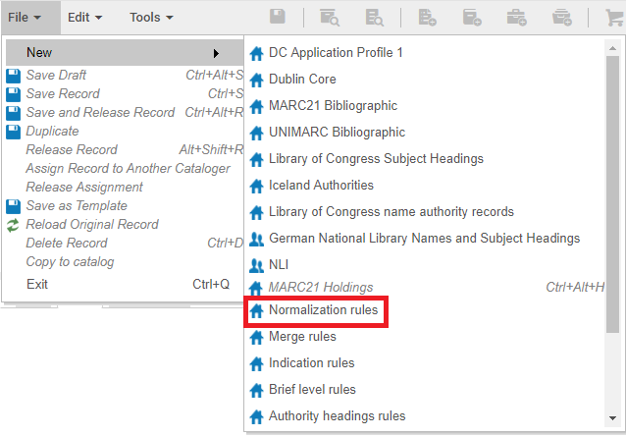

THREE

On a single open record in the metadata editor Madeline can do “Edit > Enhance the record” and run a normalization process on a record and save it.

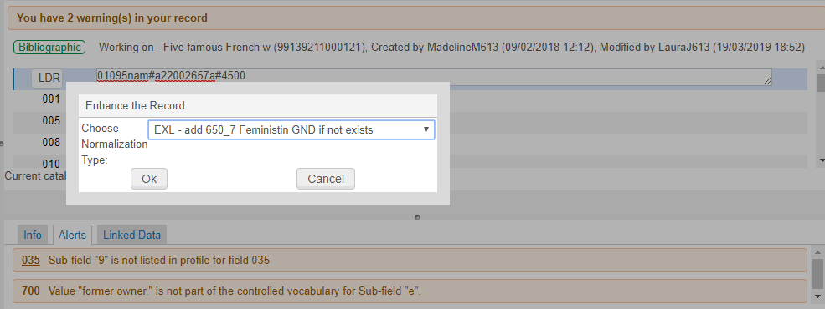

FOUR

Madeline cannot run a normalization job on a set, because role “Cataloger” cannot run jobs:
Under “Admin > manage Jobs and Sets” Madeline cannot “Run a job”



FIVE

Now instead of role “Cataloger” we give Madeline role “Catalog Manager”.

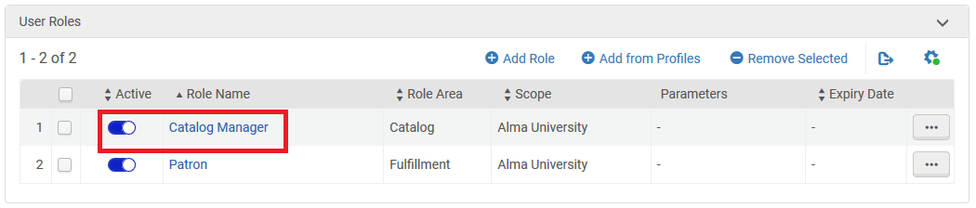

SIX

Now in addition to adding new normalization rules, editing existing normalization rules and running normalization processes in the metadata editor on a single record: Madeline can run a normalization process job on a set.

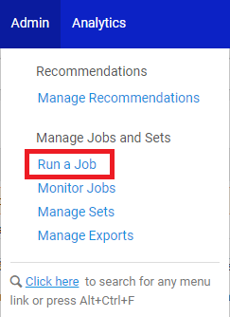

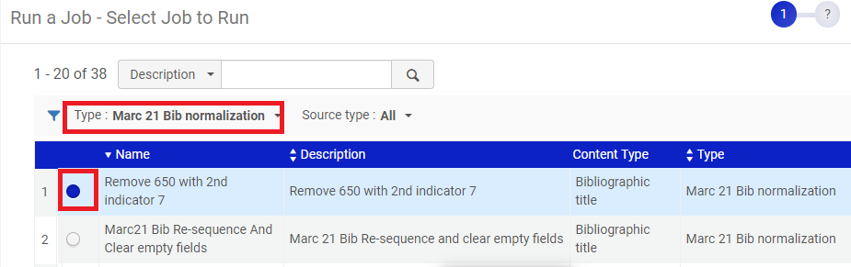

SEVEN

Note however that Madeline still has no access to edit configuration for normalization processes.

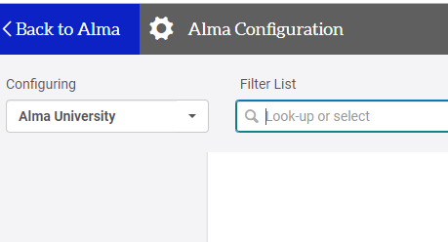

EIGHT

Now we give Madeline role “Catalog Administrator” instead of “Cataloger or Catalog manager”.
We are not including “Read Only” on this role. More on that later.

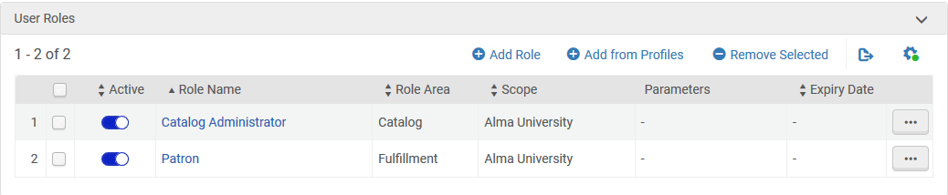

NINE

Now Madeline can edit and view normalization processes.

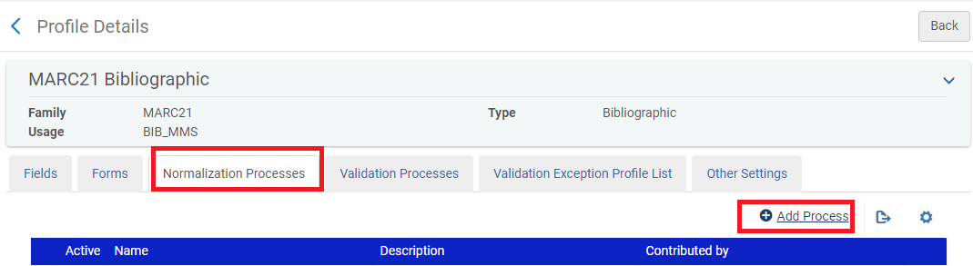

TEN

Note that as previously stated the “Catalog Administrator” could have been defined as “Read Only”.

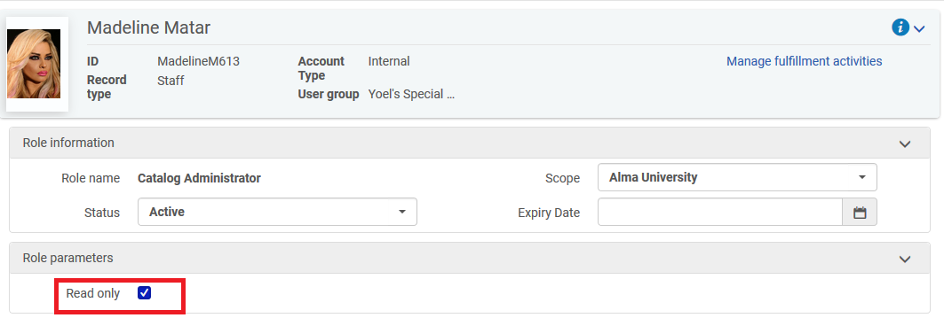

ELEVEN

When having role “Catalog Administrator” with checkbox “Read Only” Madeline can only view normalization process but not add or edit normalization processes

